CAED LAB 10

**Name: Muhammad Saad Aslam**

**I.d: FA17-BECE-0028**

**Task 1 part a:**

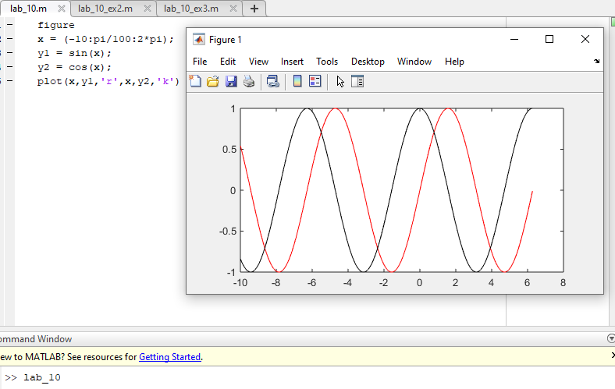

**Task 1 part b:**

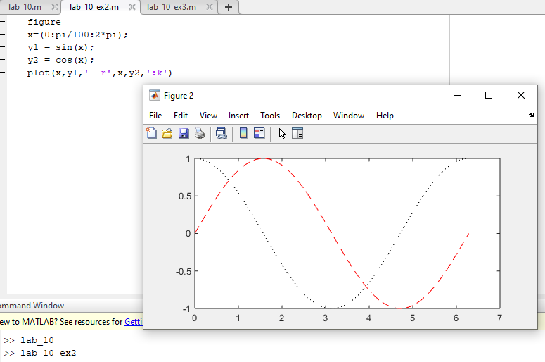

**Task 1 part c:**

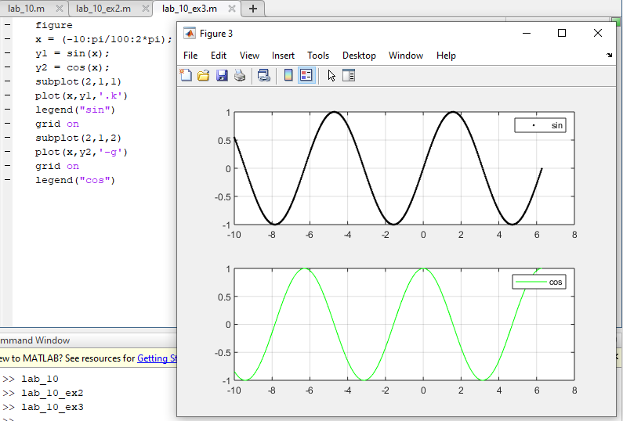

**Task 2:**

